|  |  | | | |
| --- | --- | --- | --- | --- |
|  | |  | | |
| Project: | | Mobile Mech (MM) | | |
| Team No.: | | 4 | | |
| Class: | | CSE 3310; Fall 2024 | | |
| Module: | | System Requirements Analysis (SRA) | | |
| Deliverable: | | SRA Document | | |
| **Version:** | | **[1.0]** | **Date:** | **[10/31/2024]** |

Contributors:

Sujana Kabir

Margaret Roche

Patrick Williams

Jonathan Hor

**Revision History**

| ***Version number*** | ***Date*** | ***Originator*** | ***Reason for change*** | ***High-level description of changes*** |
| --- | --- | --- | --- | --- |
| 1.0 | 10/31/2024 | Team#4 | Initial draft | Added all requirements for features |
|  |  |  |  |  |
|  |  |  |  |  |
|  |  |  |  |  |

TABLE OF CONTENTS

**1. Introduction and Project Overview 4**

**2. Objectives 5**

2.1 BUSINESS Objectives 5

2.2 SYSTEM Objectives 7

**3. Project Context Diagram 8**

**4. Systems Requirements 9**

4.1 “Registration and Login” Requirements 9

4.2 “User Profile” Requirements 12

4.3 “Communication” Requirements 14

4.4 “Mechanic Profile” Requirements 18

4.5 “Reporting” Requirements 20

4.6 “Payment” Requirements 21

4.7 “Appointment” Requirements 24

4.8 “Search” Requirements 25

**5. Software Processes and Infrastructure 27**

5.1 Hardware and Infrastructure 27

5.2 UML Diagrams 28

5.2.1 UML Diagram: “System” 28

5.2.2 UML Diagram: “Registration and Sign-in” 29

5.2.3 UML Diagram: “User Profile” 30

5.2.4 UML Diagram: “Communication” 31

5.2.5 UML Diagram: “Mechanic Profile” 32

5.2.6 UML Diagram: “Reporting” 33

5.2.7 UML Diagram: “Payment” 34

5.2.8 UML Diagram: “Appointment” 35

5.2.9 UML Diagram: “Search” 36

5.3 Conceptual Data Model 37

5.4 Screen Shots 38

5.4.1 Screen “Start Screen” 38

5.4.2 Screen “User Registration/Login Screen” 39

5.4.3 Screen “Mechanic Registration/Login Screen” 40

5.4.4 Screen “User Registration Screen” 41

5.4.5 Screen “User Registration Info Collection Screen” 42

5.4.6 Screen “User Login Screen” 43

5.4.7 Screen “Mechanic Registration Info Collection Screen” 44

5.5 Test Plan 44

**6. Assumptions and Constraints 45**

6.1 ASSUMPTIONS 45

6.2 CONSTRAINTS 45

6.3 Out-of-Scope Material 45

**7. Delivery and Schedule 46**

**8. Stakeholder Approval Form 47**

**Appendix: 48**

# 1. Introduction and Project Overview

The Mobile Mech App is an innovative Android application designed to connect users with professional mechanics, offering a convenient and efficient way to access automotive repair and maintenance services. Inspired by healthcare apps like ZocDoc or Teledoc that provide "on-demand" services, the Mobile Mech App aims to bring similar convenience to the automotive repair industry.

The android project will consist of 8 different components: Registration and Sign in, User Profile, Communication, Mechanic Profile, Reporting, Payment, Appointment, Search. When the user logs in to the application, they will be prompted to register or sign in. If they are an existing user, the user will simply sign in using their email and password. Otherwise the user will have to register. There will be both user and mechanic profiles so that both parties can have a bit of an overview. There will be ways of communication for the user with the mechanic. In the app, there will be an option to transact money from the user to the mechanic. Similar to ride apps, there will be reviews available of the mechanic so that the user can choose whom to contact best.

# 2. Objectives

## 2.1 BUSINESS Objectives

The following is a list of business objectives:

**Objective 1**:Registration and Login: Users and Mechanics must register before accessing the system. The following information is required for user registration:

* Email Address
* Password
* First name
* Last name
* Area of Residence

The following information is required for mechanic registration:

* Email address
* Password
* First name
* Last name
* Service area
* Specialties/Skills

Once registered, the user must login to access the system.

**Objective 2**:User Profile: Users will be able to view and modify their profile as needed, such as their information and area of residence to ensure applicable mechanics are recommended to them. The user profiles will be able to be viewed by mechanics once communication has been started by the user.

**Objective 3**: Mechanic Profile: Mechanics will be able to view and modify their profile as needed, such as their information, service area, and specialties/skills that they offer. The mechanic profiles will be able to be viewed by users who are deciding who they want to ask to perform some service. The mechanic profiles will have reviews associated with them in order to better educate users on the quality of work that the mechanic typically delivers.

**Objective 4**: Communication: Users and mechanics will use the communication feature in order to communicate with one another. Acts as a messaging service and is the starting point of creating appointments, payments to and from, and other features.

**Objective 5**: Reporting: Users and mechanics will be able to report inappropriate things that they see, whether in other’s individual profiles, messages sent in the communication feature, or actions witnessed in person. The reporting feature shall be present in multiple areas of the app, including in the communication section and the profiles section.

**Objective 6**: Payment: Mechanics will be able to request payment for their services, and users will be able to make those payments. Payments will originate in the communication section of the app and be handled by the system.

**Objective 7**: Appointments: Users will be able to request appointments, view set appointments, view availability of mechanics, and remove existing appointments in this section of the app. The appointments should be shown to the user in an aesthetically pleasing nature that makes it easy to see when appointments are and what availability of mechanics are.

**Objective 8**: Search: Users will be able to search for mechanics corresponding to their requested services. The results of the search should include the mechanic’s name, reviews, service, service area, and have a button to view availability.

## 2.2 SYSTEM Objectives

The following is a list of system objectives:

**Objective 1**: The system will be an Android-based Mobile system

**Objective 2**: ReactNative will be utilized to develop

**Objective 3**: The system will offer a user-friendly interface to enhance user experience

**Objective 4**: The system will be able to add new features in the future based on user preference and industry demand.

# 3. Project Context Diagram

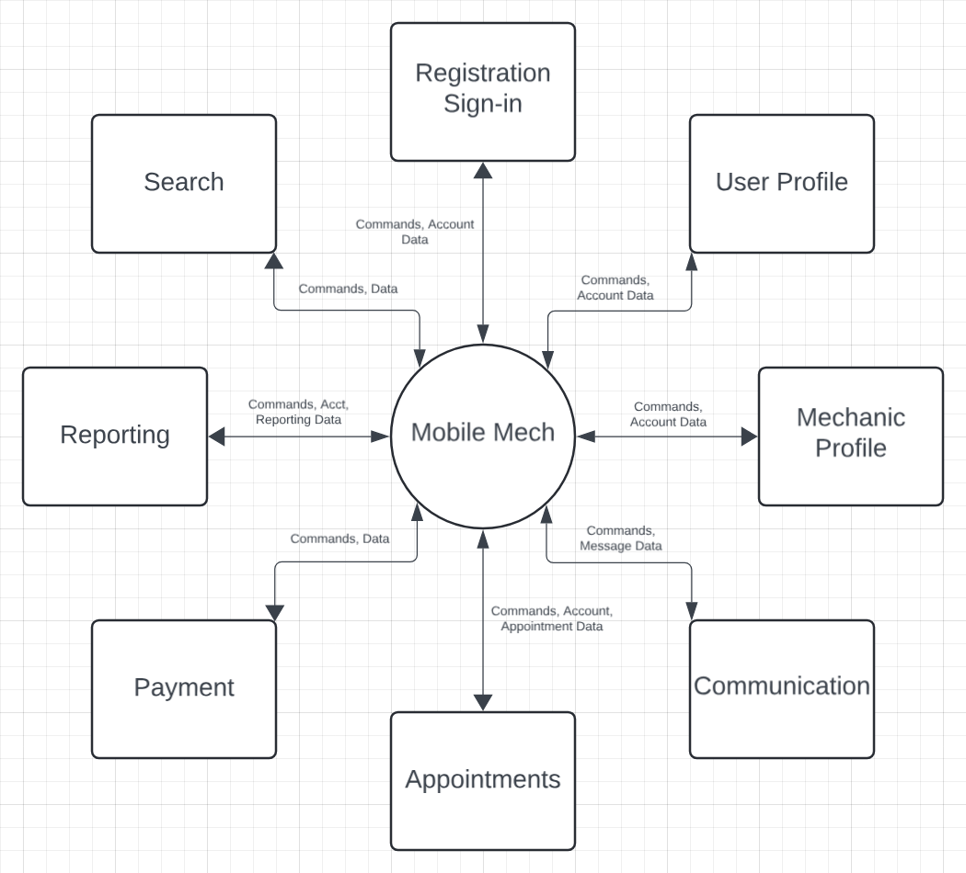

# 4. Systems Requirements

{**Use the designated Requirements Form and insert all forms below in its related section.**}

## 4.1 “Registration and Login” Requirements

| **Requirement Title:** | Registration and Login |
| --- | --- |
| **Sequence No:** | 001 |
| **Short Description:** | Registering new users |
| **Description:** | Users and mechanics must register accordingly before accessing the application. For regular consumers, the following information will be collected:   * Name {First, Last name} * Email address * Password * Area   For mechanics, the following information will be collected:   * Name {First, Last name} * Email Address * Password * Specialities (skills) * Service Area   Users can press:   * “I’m a mechanic” button * “I’m a user” button * Submit * Cancel * Exit screen |
| **Pre-Conditions:** | * App must be loaded in order to process the request * Duplicate registration (matching emails) is not allowed |
| **Post Conditions:** | * Account created successfully, information saved |
| **Other Attributes:** | * None |

| **Requirement Title:** | Registration and Login |
| --- | --- |
| **Sequence No:** | 002 |
| **Short Description:** | Logging in existing users |
| **Description:** | Users must be authenticated before accessing the app. The user must enter:   * Email address * Password   The user can press:   * Submit * Forgot password * Cancel * Exit screen |
| **Pre-Conditions:** | * App must be loaded in order to make requests * User must already be registered |
| **Post Conditions:** | * User can access the app from the perspective of their role (Mechanic // User) |
| **Other Attributes:** | * None |

| **Requirement Title:** | Registration and Login |
| --- | --- |
| **Sequence No:** | 003 |
| **Short Description:** | Forgot Password |
| **Description:** | Users can request to reset their password. The user must enter:   * Email address   An email will be sent to the user’s email address. Once the user clicks on the link in the email, the user must enter:   * New password   The user can press:   * Submit * Cancel * Exit screen |
| **Pre-Conditions:** | * App must be loaded in order to make requests * Email must exist and be associated with an account |
| **Post Conditions:** | * Password changed successfully, new password set |
| **Other Attributes:** | * None |

## 

## 4.2 “User Profile” Requirements

| **Requirement Title:** | User Profile |
| --- | --- |
| **Sequence No:** | 001 |
| **Short Description:** | Profile of customers searching for Mechanics |
| **Description:** | Users can customize and view a profile of themselves. The default viewing of a profile is static. It displays:   * User name * User location (approximate - by city) * User profile picture   From the profile, the user can choose to:   * Change user name * Change user location * Change user profile picture * Change user password |
| **Pre-Conditions:** | * App must be loaded in order to make requests * Email must exist and be associated with an account * Password must be set |
| **Post Conditions:** | * Desired information was successfully updated and is displayed accordingly |
| **Other Attributes:** | None |

| **Requirement Title:** | User Profile |
| --- | --- |
| **Sequence No:** | 002 |
| **Short Description:** | Altering profile of customers searching for Mechanics |
| **Description:** | Users can customize and view a profile of themselves. Users must be authenticated before altering their profile. The user must enter:   * Password   After authenticating, users can alter:   * User name * User location * User profile picture * User password |
| **Pre-Conditions:** | * App must be loaded in order to make requests * Email must exist and be associated with an account * Password must be set |
| **Post Conditions:** | * User profile information altered successfully |
| **Other Attributes:** | None |

## 

## 4.3 “Communication” Requirements

| **Requirement Title:** | Communication |
| --- | --- |
| **Sequence No:** | 001 |
| **Short Description:** | View Inbox and Retrieve Messages |
| **Description:** | When a user selects Messages it directs them to the Inbox where all previous and new messages are retrieved and displayed.  While in the Inbox, users can select among the following:   * Send Message * Mute Chat * Request Payment * Send Payment |
| **Pre-Conditions:** | * App must be loaded in order to process the request * User must have an existing account |
| **Post Conditions:** | * Inbox information is updated accordingly if a message is new or viewed |
| **Other Attributes:** | None |

## 

| **Requirement Title:** | Communication |
| --- | --- |
| **Sequence No:** | 002 |
| **Short Description:** | Send Message to another user |
| **Description:** | User selects Compose Message to reply or create a new message. A text box is displayed for user input.  After the user is satisfied with their input, the user selects Send Message to initiate or reply to a conversation. |
| **Pre-Conditions:** | * App must be loaded in order to process the request * User must have an existing account |
| **Post Conditions:** | * Inbox information is updated accordingly * User receives confirmation that their message was successfully sent |
| **Other Attributes:** | * Non-mechanic users initiate conversations |

## 

| **Requirement Title:** | Communication |
| --- | --- |
| **Sequence No:** | 003 |
| **Short Description:** | Request Payment via message |
| **Description:** | After a user and Mechanic conversates, the Mechanic is able to Request Payment.  The Mechanic requests payment via messaging and the user receives a message that directs them to Payment. |
| **Pre-Conditions:** | * App must be loaded in order to process the request * User must have an existing account |
| **Post Conditions:** | * Inbox information is updated accordingly |
| **Other Attributes:** | * Mechanic users can only request payment |

| **Requirement Title:** | Communication |
| --- | --- |
| **Sequence No:** | 004 |
| **Short Description:** | Send Payment via message |
| **Description:** | After the user opens and views the invoice from the Mechanic, the user is directed to Payment. |
| **Pre-Conditions:** | * App must be loaded in order to process the request * User must have an existing account |
| **Post Conditions:** | * Inbox information is updated accordingly * User is directed to Payment |
| **Other Attributes:** | None |

## 

## 4.4 “Mechanic Profile” Requirements

| **Requirement Title:** | Mechanic Profile |
| --- | --- |
| **Sequence No:** | 001 |
| **Short Description:** | Profile of Mechanics searching for customers |
| **Description:** | Mechanics can customize and view a profile of themselves. The default viewing of a profile is static. It displays:   * Mechanic name * Mechanic rating * Mechanic location (approximate - by city) * Mechanic profile picture * Mechanic price range * Mechanic services * Mechanic reviews   From the profile, the mechanic can choose to:   * Change Mechanic name * Change Mechanic location * Change user profile picture * Change mechanic price range * Change mechanic services * Change user password |
| **Pre-Conditions:** | * App must be loaded in order to make requests * Email must exist and be associated with an account * Password must be set |
| **Post Conditions:** | * Desired information was successfully updated and is displayed accordingly |
| **Other Attributes:** | None |

| **Requirement Title:** | Mechanic Profile |
| --- | --- |
| **Sequence No:** | 002 |
| **Short Description:** | Profile of Mechanics searching for customers |
| **Description:** | Mechanics can customize and view a profile of themselves. Mechanics must be authenticated before altering their profile. The Mechanic must enter:   * Password   After authenticating, Mechanics can alter:   * Mechanic name * Mechanic location (approximate - by city) * Mechanic profile picture * Mechanic price range * Mechanic services * Mechanic password   Mechanics cannot alter their ratings and reviews, which are permanently affixed to the profile unless removed by the app developers. |
| **Pre-Conditions:** | * App must be loaded in order to make requests * Email must exist and be associated with an account * Password must be set |
| **Post Conditions:** | * Desired information was successfully updated and is displayed accordingly |
| **Other Attributes:** | None |

## 

## 4.5 “Reporting” Requirements

| **Requirement Title:** | Reporting |
| --- | --- |
| **Sequence No:** | 001 |
| **Short Description:** | Report messages or users |
| **Description:** | The user may report a message or profile if either one violates the rules. A report may be filed by:   * An existing message in the inbox * Reporting a user or mechanic profile   A text box will appear first so the user may input why they are filing a report.   * There are options throughout the process to return home in case the reportee changes their mind   After the user submits the report they have an option to block the account. |
| **Pre-Conditions:** | * App must be loaded in order to process the request * Reportee must have an existing account |
| **Post Conditions:** | * Information is updated after the user submits a report * Reportee no longer sees reported account if they selected to block user |
| **Other Attributes:** | None |

## 

## 4.6 “Payment” Requirements

| **Requirement Title:** | Payment |
| --- | --- |
| **Sequence No:** | 001 |
| **Short Description:** | Selecting payment method |
| **Description:** | The user can initiate a payment method by selecting one of the options below:   * Credit/Debit Card payment * Cash payment   This allows the user to pay for the services they have already requested  The user can press:   * Cancel * Exit screen |
| **Pre-Conditions:** | * App must be loaded in order to process the request * User must have completed the service selection process * User must have a valid payment option available |
| **Post Conditions:** | * If user selects a credit card, they will be given an option to enter their card details * If user selects cash method, they will be prompted to provide cash |
| **Other Attributes:** | * The system should handle the process to switch payment method |

| **Requirement Title:** | Payment |
| --- | --- |
| **Sequence No:** | 002 |
| **Short Description:** | Credit Card payment method |
| **Description:** | The user selects the credit card payment method and proceeds to enter the required details:   * Card number * CVV * Name & Address   This allows the user to pay for the services they have already requested by credit card  The user can press:   * Cancel * Exit screen * Switch payment method |
| **Pre-Conditions:** | * App must be loaded in order to process the request * User must have selected the credit card payment option * User must have a valid credit card |
| **Post Conditions:** | * If a user enters a valid credit card, the payment is authorized and a confirmation email will be sent. * If payment fails, user is prompted to select again |
| **Other Attributes:** | * The system should handle the process to re-enter credit card information or switch/cancel |

| **Requirement Title:** | Payment |
| --- | --- |
| **Sequence No:** | 003 |
| **Short Description:** | Cash payment method |
| **Description:** | The user selects the cash payment method and proceeds to enter the required details:   * Amount of transaction * Name & Address   This allows the user to pay for the services they have already requested by cash  The user can press:   * Cancel * Exit screen * Switch payment method |
| **Pre-Conditions:** | * App must be loaded in order to process the request * User must have selected the cash payment option * User must have a sufficient cash |
| **Post Conditions:** | * The mechanic is notified for a pending cash payment * If payment fails, user is prompted to select again |
| **Other Attributes:** | * The system should handle the tracking of cash payments or switch/cancel |

## 4.7 “Appointment” Requirements

| **Requirement Title:** | Appointment |
| --- | --- |
| **Sequence No:** | 001 |
| **Short Description:** | Setting up appointment between user and mechanic |
| **Description:** | The user will be able to do the following of these:   * Selecting the mechanic * editing/ canceling the appointment * Add to calendar for setting up a reminder   The system should make sure that all the appointments are properly set by the users and notified to the mechanics so that both parties are able to manage their appointments effectively.  The user can press:   * Confirm appointment * Cancel appointment * Exit screen |
| **Pre-Conditions:** | * App must be loaded in order to process the request * User and Mechanic both must be registered and logged in the app * Both the availability of the user and mechanic must be matching |
| **Post Conditions:** | * Appointment status updated to the system * Added to the calender of both user and mechanic * Notification about the appointment is sent to both user and mechanic |
| **Other Attributes:** | * The system should ensure that all the changes made into the existing appointment should be alerted to the mechanic and user |

## 

## 4.8 “Search” Requirements

| **Requirement Title:** | Search |
| --- | --- |
| **Sequence No:** | 001 |
| **Short Description:** | Enables the user to search for services |
| **Description:** | The user will be able to search for services, for example, “oil changes.” The user must enter:   * Requested services in search box   The user can press:   * Search button * Cancel * Exit screen |
| **Pre-Conditions:** | * The app and data must be properly loaded so that the request can be processed * User is logged in |
| **Post Conditions:** | * Query made by system towards database |
| **Other Attributes:** | * None |

| **Requirement Title:** | Search |
| --- | --- |
| **Sequence No:** | 002 |
| **Short Description:** | System queries the database, results returned |
| **Description:** | The system will take the request from Search sequence number 001(above) and query the database, and then deliver the results to the user.  The user will be able to scroll and press:   * View mechanic profile * Schedule with mechanic * Return to search * Cancel * Exit screen |
| **Pre-Conditions:** | * The app and data must be properly loaded so that the request can be processed * User is logged in |
| **Post Conditions:** | * Results delivered by system |
| **Other Attributes:** | * System should be able to return results not directly like the search input to account for user mistyping/spelling something incorrectly. |

# 5. Software Processes and Infrastructure

## 5.1 Hardware and Infrastructure

For building the application, we are using version 0.74.5 of the react-native framework with version 51.0.28 of expo that acts as a set of tools on top of react native. It also helps to run, debug, and test the app. These tools allow us to build native applications for both Android and iOS devices. With that, comes with all of the relevant dependencies. For the back end services of the application, such as user authentication or querying, we are using Google Firebase, which is implemented in our application through their API (version 10.14.1.)

## 

## 5.2 UML Diagrams

### 5.2.1 UML Diagram: “System”

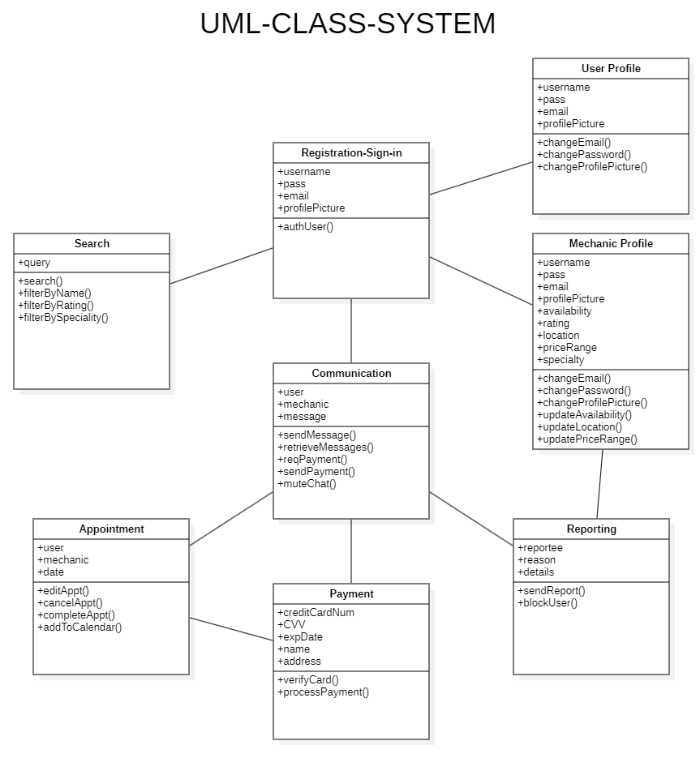

### 

### 5.2.2 UML Diagram: “Registration and Sign-in”

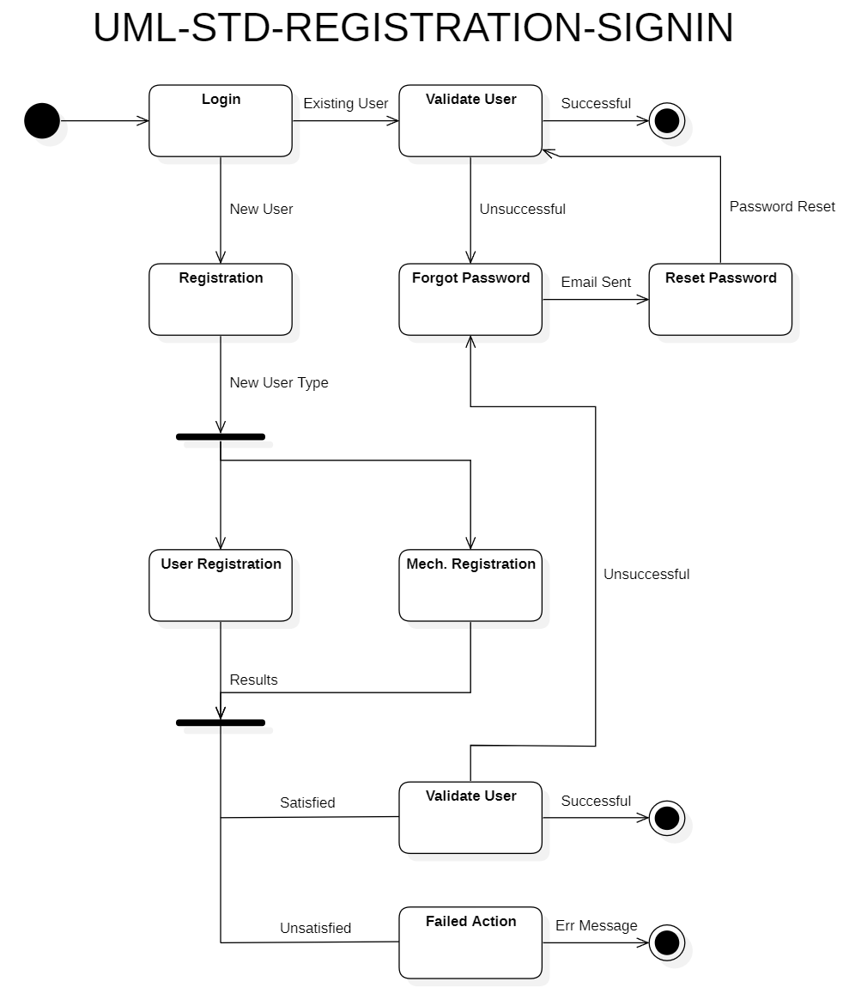

### 5.2.3 UML Diagram: “User Profile”

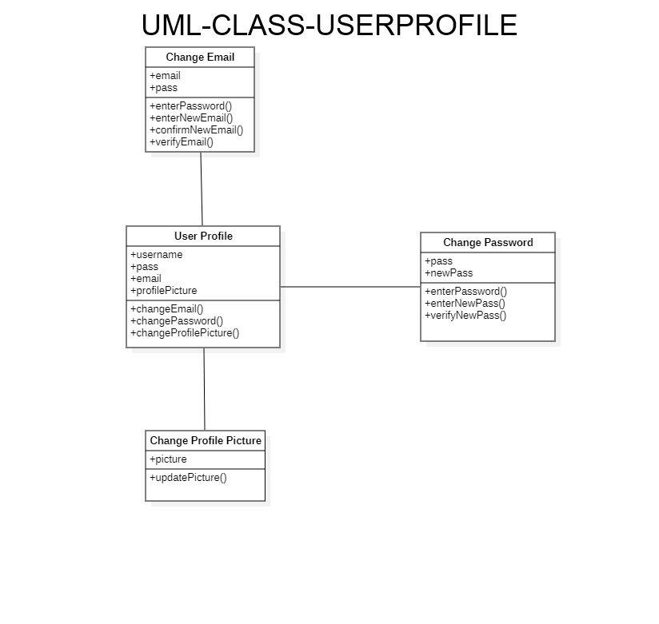

### 5.2.4 UML Diagram: “Communication”

### 5.2.5 UML Diagram: “Mechanic Profile”

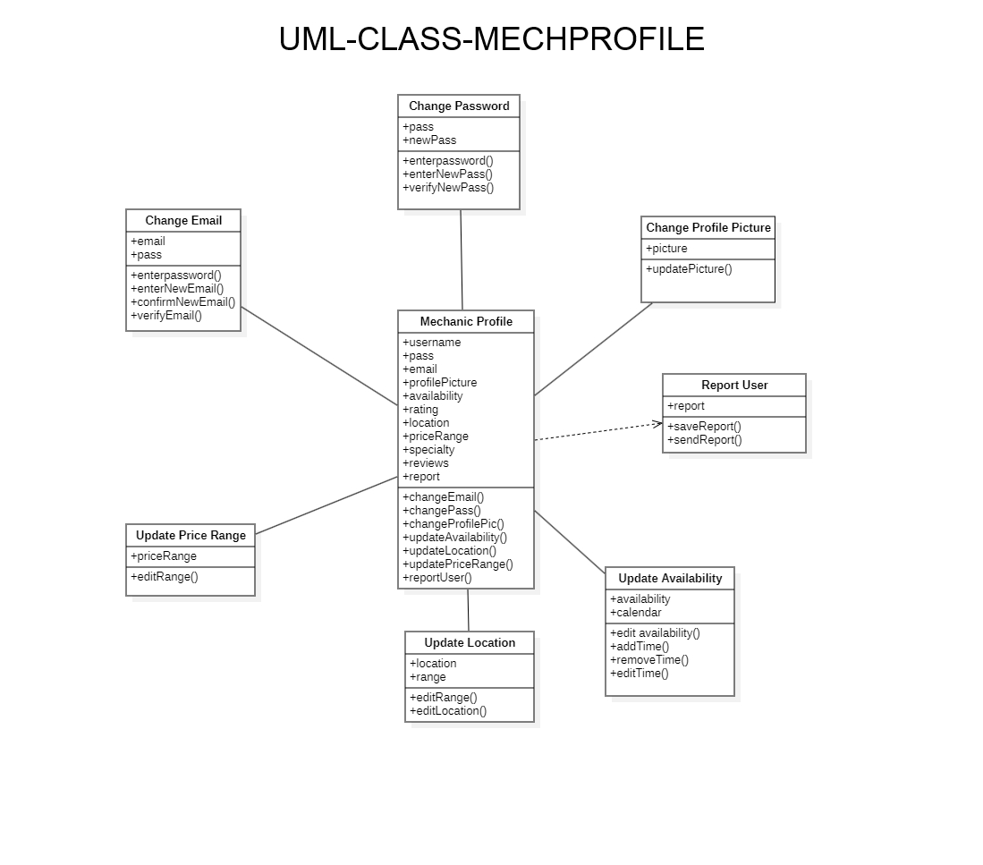

### 5.2.6 UML Diagram: “Reporting”

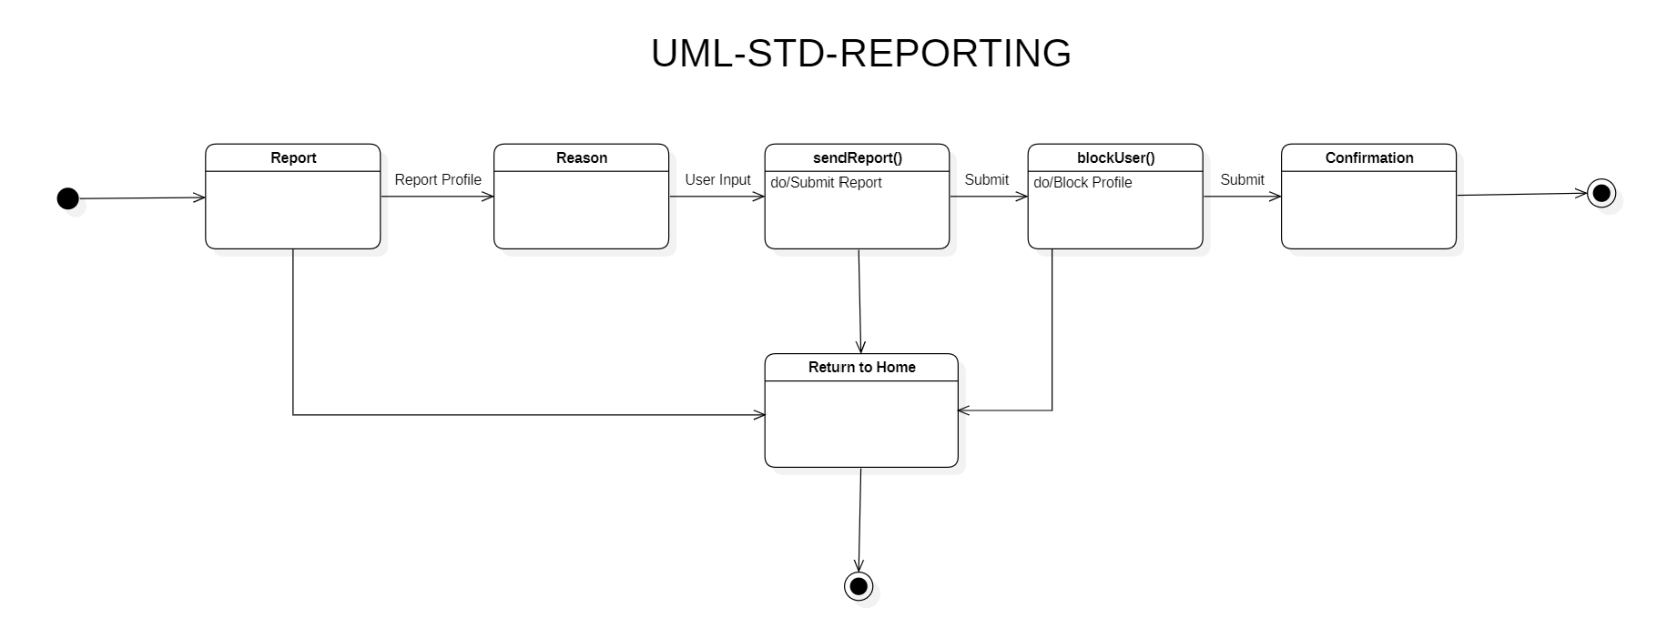

### 5.2.7 UML Diagram: “Payment”

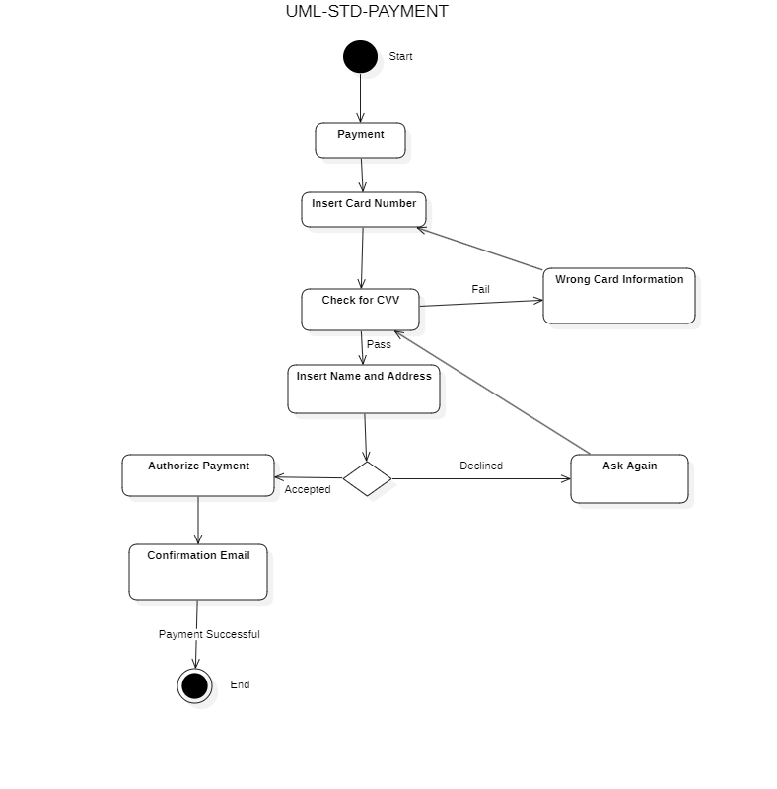

### 5.2.8 UML Diagram: “Appointment”

## 

### 5.2.9 UML Diagram: “Search”

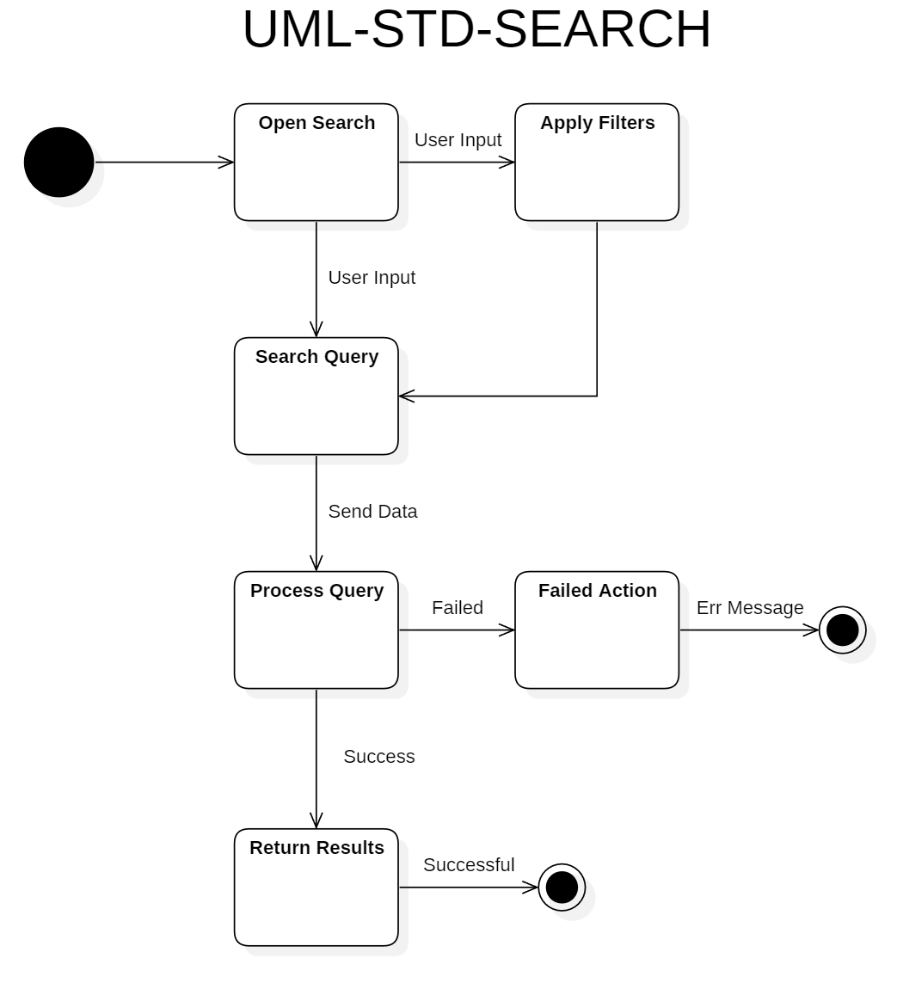

## 5.3 Conceptual Data Model

We will be using Firebase and its Firestore functionality for all of our database needs. We will be able to access the databases through Firebase’s API, and it has methods for maintaining security, performing queries and returning results, and asynchronously adding entries into the database, among other features.

## 

## 5.4 Screen Shots

### 5.4.1 Screen “Start Screen”

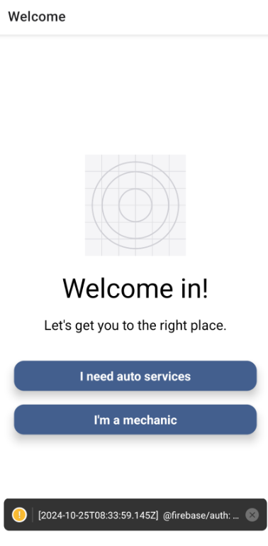

### 

### 5.4.2 Screen “User Registration/Login Screen”

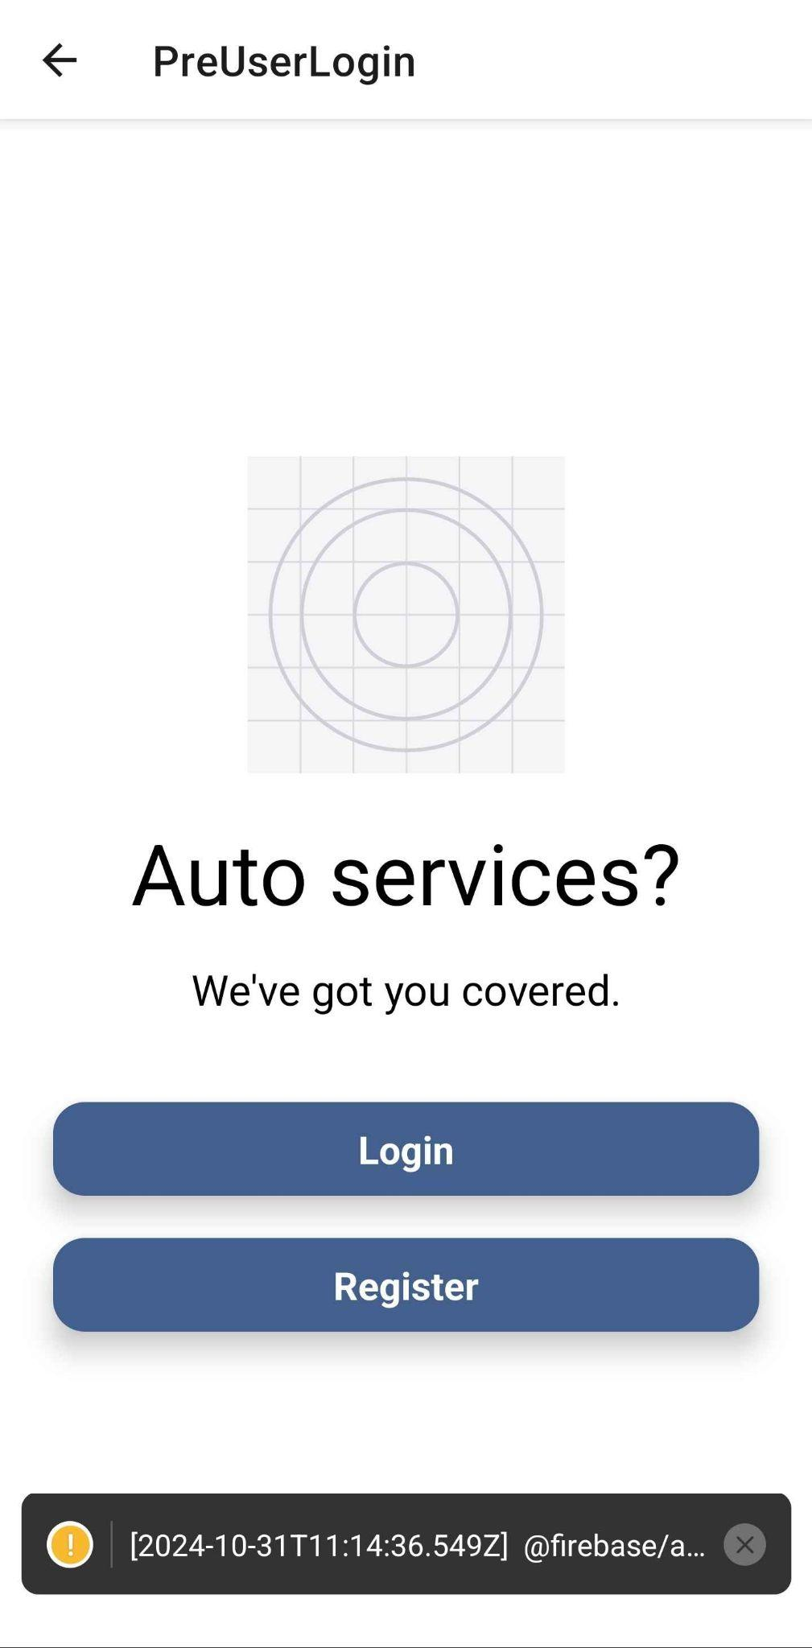

### 

### 5.4.3 Screen “Mechanic Registration/Login Screen”

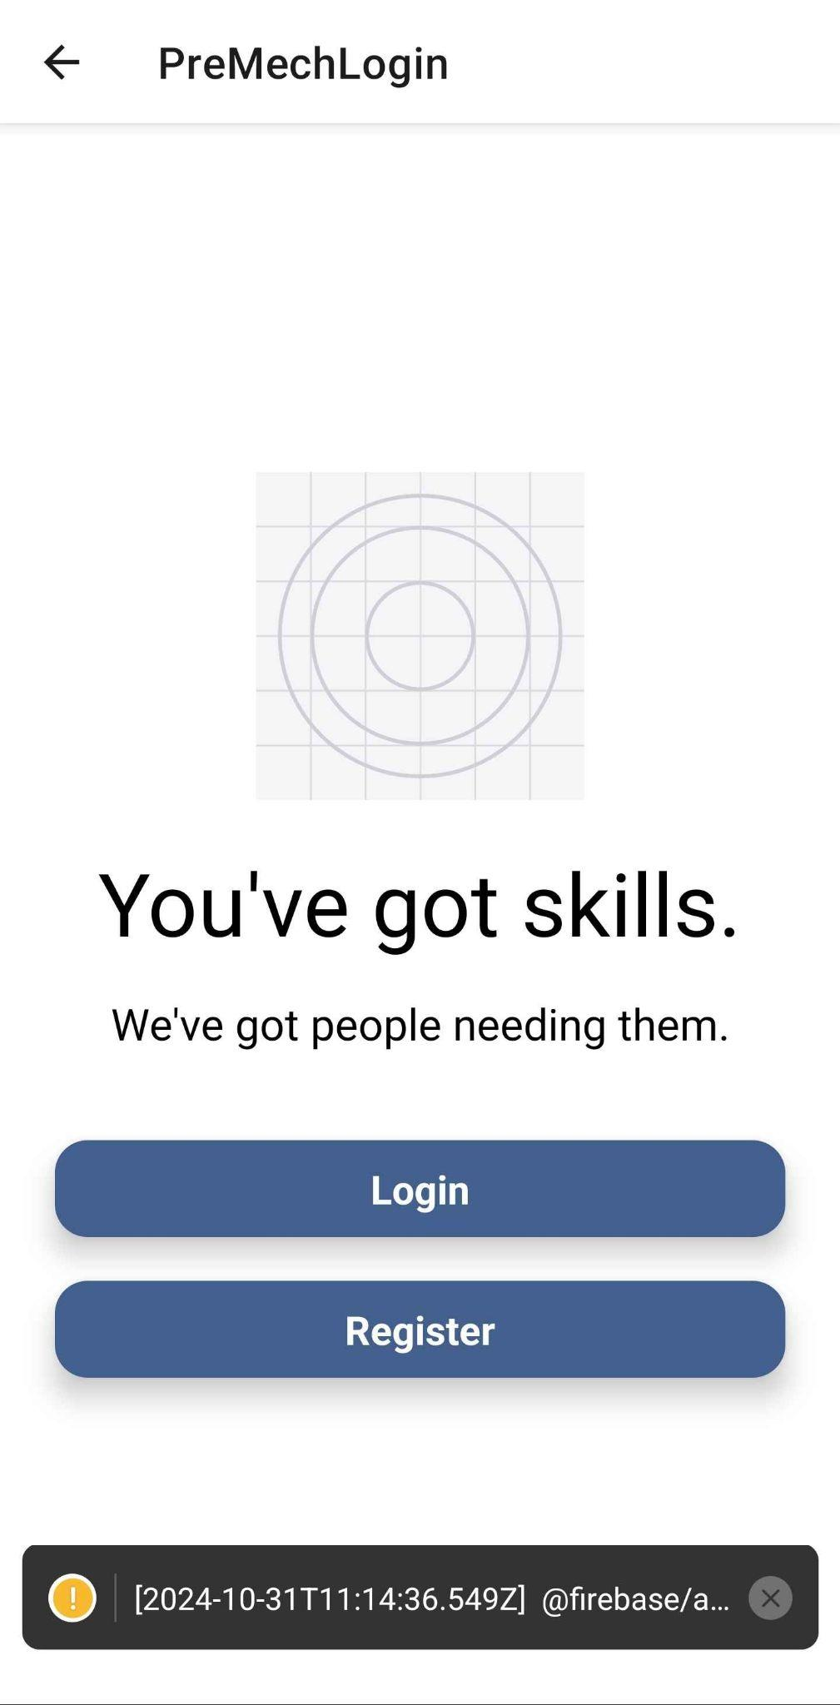

### 

### 5.4.4 Screen “User Registration Screen”

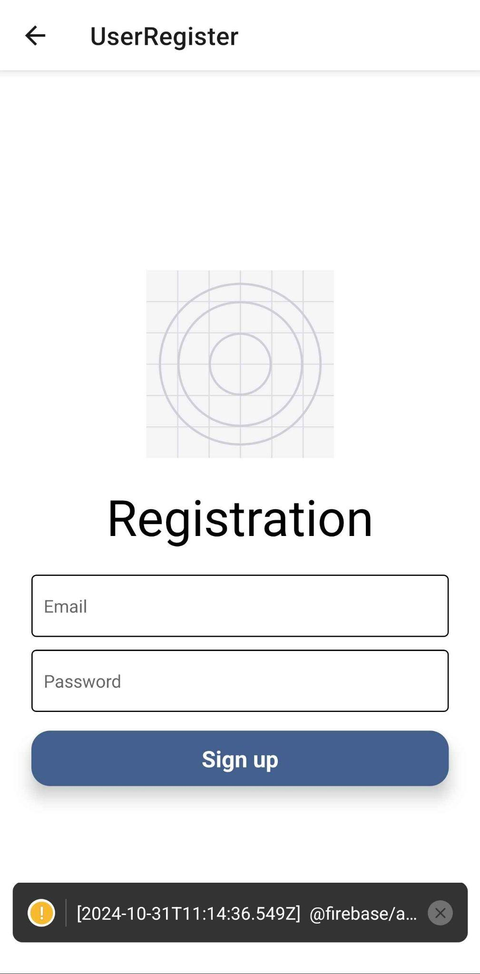

### 

### 5.4.5 Screen “User Registration Info Collection Screen”

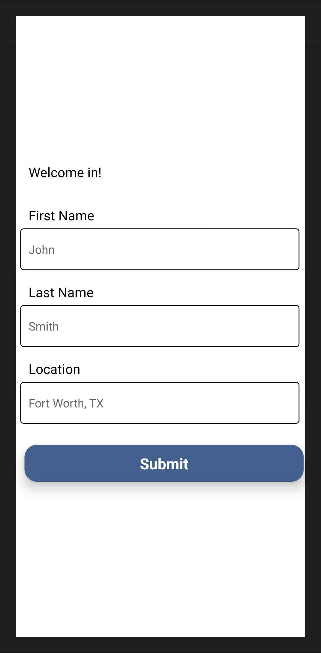

### 

### 5.4.6 Screen “User Login Screen”

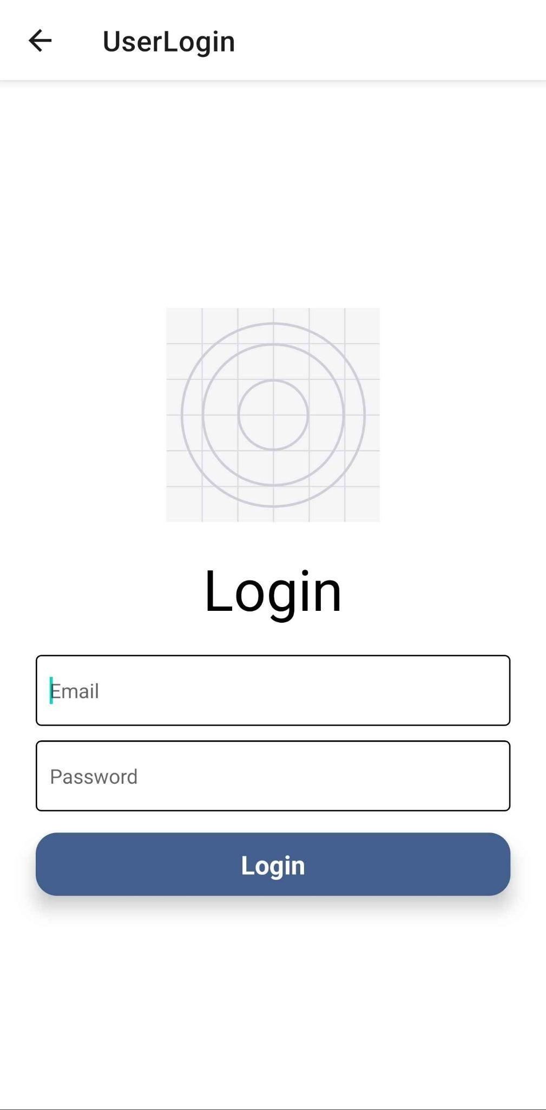

### 

### 5.4.7 Screen “Mechanic Registration Info Collection Screen”

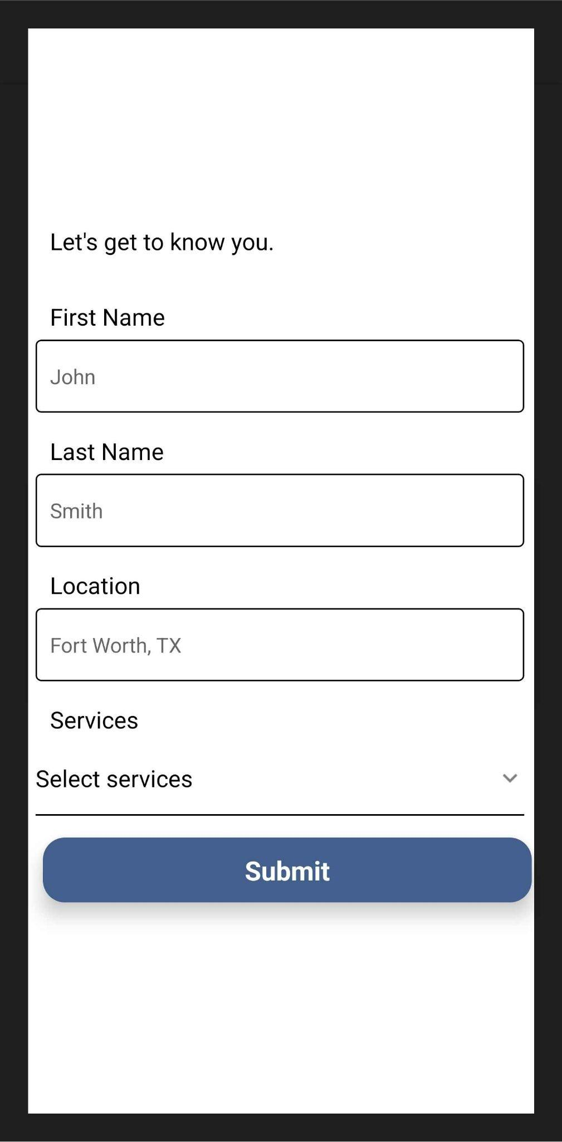

## 5.5 Test Plan

A test plan will be provided at a later stage of the project.

# 6. Assumptions and Constraints

## 6.1 ASSUMPTIONS

The following is a list of assumptions:

* Assume all users over the age of 18
* Ignore all financial and tax reporting details
* Code is not written with high-standard security protocols in mind
* Scalability is not a necessary consideration
* Code is not written with high-standard optimization in mind

## 6.2 CONSTRAINTS

The following is a list of constraints:

* The team lacks Android development skills
* Schedule very aggressive
* Limited experience with UI/UX
* Relying on third party software
* Development team is new to working together

## 6.3 Out-of-Scope Material

The following is a list of “out of scope” material:

* Post Project maintenance is not covered
* Proper security feature implementation
* Cross-platform compatibility
* Design of proper and thorough accessibility features
* External system integration

# 7. Delivery and Schedule

{List all tasks/milestones from the start of the project to the end with specific dates for both Anticipated Start & End Dates, Remove this guideline}

| Task/Milestone Description | Anticipated Start Date | Anticipated End Date | Status  {Complete, In Progress, To Be Completed-TBC} | Comments  (Deliverable plus the team member working on the listed item) |
| --- | --- | --- | --- | --- |
| Prepare UML diagrams | 9/10/2024 | 9/26/2024 | Complete | Deliverable 🡺 UML document (TEAM) |
| Create an official SRA document | 9/27/2024 | 10/31/2024 | In Progress | Deliverable will be the SRA document. All stakeholders agree on the content of the SRA by signing in section 8. |
| Registration and Sign-in | 10/11/24 | 10/17/24 | Complete | Patrick Williams |
| User profile | 10/31/2024 | 11/18/24 | TBC | Margaret Roche |
| Communication | 10/31/2024 | 11/18/24 | TBC | Jonathan Hor |
| Mechanic Profile | 10/31/2024 | 11/18/24 | TBC | Margaret Roche |
| Reporting | 10/31/2024 | 11/18/24 | TBC | Jonathan Hor |
| Payment | 10/20/24 | 11/15/24 | TBC | Sujana Kabir |
| Appointment | 10/25/24 | 11/18/24 | TBC | Sujana Kabir |
| Search | 10/25/24 | 11/10/24 | TBC | Patrick Williams |
| Test Plan Delivery | 11/1/2024 | 11/14/2024 | TBC | The Team Deliverable will be the Test plan document. |
| External Documentation (i.e., User Manual) | 11/26/2024 | 12/1/2024 | TBC | The team Deliverable will be a User Manual. |
| Final Milestone: Project Delivery and Team Presentation | 11/26/2024 | 12/3/2024 | TBC | The Team Deliverable will be the final project binder plus the product demo |

# 8. Stakeholder Approval Form

| Stakeholder Name | Stakeholder Role | Stakeholder Comments | Stakeholder Approval Signature and Date |
| --- | --- | --- | --- |
| Bahram Khalili | Client |  |  |
| Tuan Dang | Client Project Manager |  |  |
| Margaret Roche | Developer |  | Margaret Roche  10/30/2024 |
| Patrick Williams | Developer |  | Patrick Williams  10/30/2024 |
| Sujana Kabir | Developer |  | Sujana Kabir  10/30/2024 |
| Jonathan Hor | Developer |  | Jonathan Hor  10/30/2024 |

# Appendix:

Firebase

[Firebase Official Site](https://firebase.google.com/)

React Native

[React Native Official Site](https://reactnative.dev/)